



**Ing. Jaroslav Martinek**

+420 602 503 617  
[jarda@dobramesta.cz](mailto:jarda@dobramesta.cz)

Manual for using

the map portal

**stavbycyklo.cz**

**Českomoravský cyklokoordinátor, z.s.**

**IČ: 09993339**

Sídlo: Náves Svobody 8/14, Holice, 779 00 Olomouc



**Bc. Tomáš Weber**

+420 123 456 789  
info@cyklokoordinator.cz

**Verze dokumentu:**

2025.15.01

**Datum vytvoření:**

20. listopadu 2022

**Poslední aktualizace:**

15. ledna 2025

# Contents

Contents 2

Historie dokumentu 5

Section A 9

Section B 10

Section C 12

Working with data 13

Working with data in the viewing mode 13

Editing mode 15

Section A 16

Section B 17

Section C 19

Section E 20

Working with data 22

Working with data in editing mode 22

Creating a new line 22

Deleting a line 22

Duplicating a line 23

Splitting the lines 23

Connecting the lines 23

Move the object 23

Data backup 27

BACKGROUND INFORMATION

# Historie dokumentu

|  |  |  |  |
| --- | --- | --- | --- |
| Datum | Verze | Autor | Popis úprav |
| 20.11.2022 | 2022.11.01 |  | Tvorba manuálu |
| 8.3.2023 | 2023.03.08 |  | Úprava manuálu dle změn funcionalit |
| 19.3.2023 | 2023.03.19 |  | Úprava manuálu dle změn funcionalit |
| 15.1.2025 | 2025.01.15 |  | Úprava manuálu dle nového vizuálního stylu a změn funcionalit |

**Where the map portals can be found**

Map portals for individual regions can be found on web sites in the form XXX.stavbycyklo.cz where XXX stands for the abbreviation of the region. Please find below the web addresses of the respective region portals.

* The capital city of Prague [praha.stavbycyklo.cz](http://praha.stavbycyklo.cz/)
* Central Bohemian Region [sckr.stavbycyklo.cz](http://sckr.stavbycyklo.cz)
* South Bohemian Region [jckr.stavbycyklo.cz](http://jckr.stavbycyklo.cz)
* Pilsen Region [pzkr.stavbycyklo.cz](http://pzkr.stavbycyklo.cz)
* Karlovy Vary Region [kvkr.stavbycyklo.cz](http://kvkr.stavbycyklo.cz)
* Ústí nad Labem Region [ulkr.stavbycyklo.cz](http://ulkr.stavbycyklo.cz)
* Liberec Region [lbkr.stavbycyklo.cz](http://lbkr.stavbycyklo.cz)
* Hradec Králové Region [khkr.stavbycyklo.cz](http://khkr.stavbycyklo.cz)
* Pardubice Region [pukr.stavbycyklo.cz](http://pukr.stavbycyklo.cz)
* Vysočina Region [krvys.stavbycyklo.cz](http://krvys.stavbycyklo.cz)
* South Moravian Region [jmkr.stavbycyklo.cz](http://jmkr.stavbycyklo.cz)
* Olomouc Region [olkr.stavbycyklo.cz](http://olkr.stavbycyklo.cz)
* Zlín Region [zlkr.stavbycyklo.cz](http://zlkr.stavbycyklo.cz)
* Moravian-Silesian Region [mskr.stavbycyklo.cz](http://mskr.stavbycyklo.cz)

**Map portal environment**

The map portal can be displayed in two modes - **viewing** and **editing**. As the name of each mode implies, the first one is for viewing data, while the latter one for editing data.

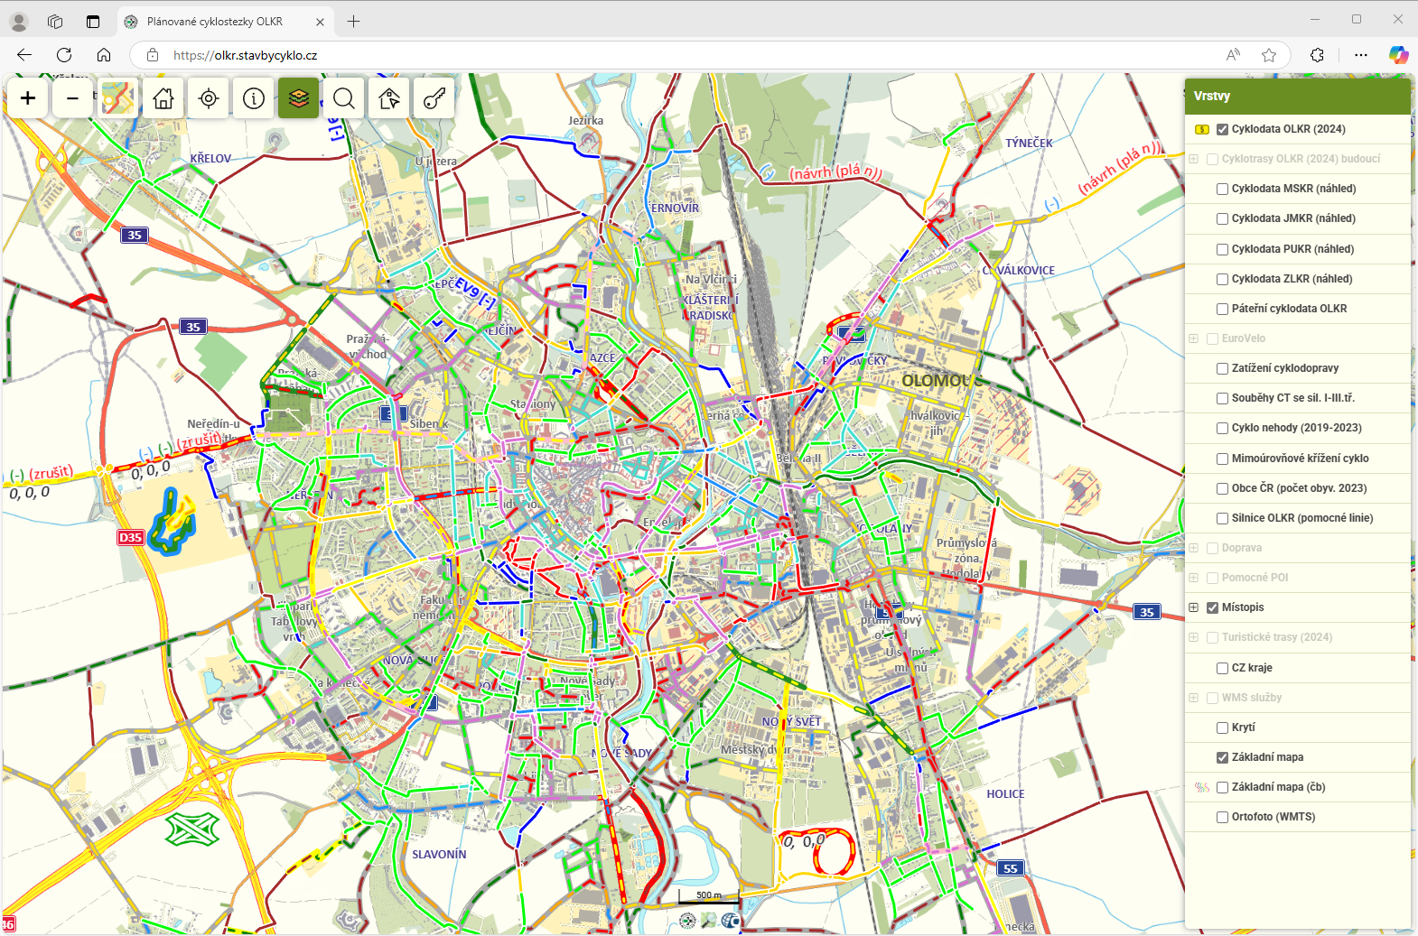

VIEWING

MODE

The viewing mode is intended for visitors who want to browse the data published on the map portal. Nothing can be edited in this mode.

There are several toolbars in the viewing mode. For the purpose of presenting the desktop, these are divided into 3 sections: A, B and C. 

C

A

B

### Section A

The first toolbar is located at the top left of the desktop. This toolbar contains 10 icons in viewing mode.

Real estate cadastre

List of layers

Change the map base

Zoom in the map

My location

workspace



Zoom out the map

Default range

Legend

Login

Search

* ***The first two icons***  **and**  **are used to zoom in and out the map.** You can also use the mouse wheel to zoom the map.
* 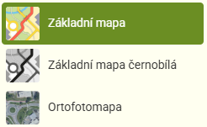Click on *the third icon* with the map  to display the **menu for selecting the map base**. You can select a basic colour map, a black and white version or an orthophoto map (aerial image).
* *The fourth icon*  is used to return to the **home position** on the map.
* *The fifth icon*  is used to zoom the map to the **current location**. You need to have location sharing enabled to use this option.
* *The icons six, seven and eight are used to display the* ***various work windows*** *in Section B.* Clicking on the *sixth icon*  displays the legend, clicking on the *seventh icon*  displays the list of layers, and clicking on *the eighth icon*  displays the search window. The currently selected option is highlighted in green. To hide the window, just click on the icon again.
* 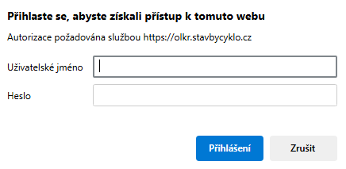 Use the *ninth icon* to activate the option to display **information from the Real Estate Cadastre**. Clicking on the desktop will open a new browser window at <https://nahlizenidokn.cuzk.gov.cz/>. If this option is activated, the icon is green.
* After clicking on the *last icon*, a window for **logging** into the portal's editing mode will appear.

### Section B

The second section of the desktop changes based on what the visitor selects by clicking the icons in Section A. In the basic setup, this section displays the *Layers window*. However, you can use the icons in Section A to display the *Search window* or *Legend.*

You can also hide this section completely by clicking on the icon in section A of the currently displayed window. *(i.e. I have the Legend displayed, so I click on the Legend icon and the whole section is hidden.)*

*Layers window -* you can turn on and off the map layers. The most important is the data layer - it should always be turned on by default. This layer is called **Cyklodata XXX (2025)** where XXX is the Region abbreviation and the date is the date of the data update.

*Search window -* you can search and filter published data using various filters.

*Legend window -* here you find the legend of the displayed lines. The legend displays abbreviated names with the line color and pictogram displayed. In case the visitor does not know what the respective abbreviations mean, it is possible to hover over thelegend itemand a description of the item will be displayed*.* 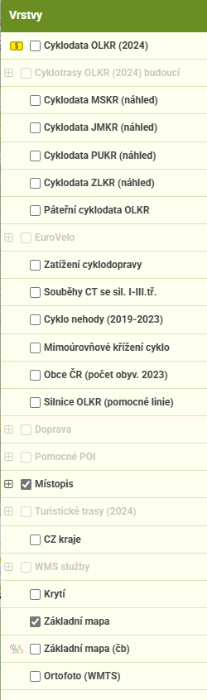 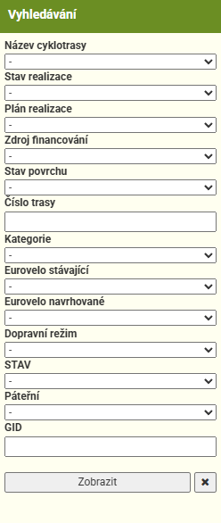 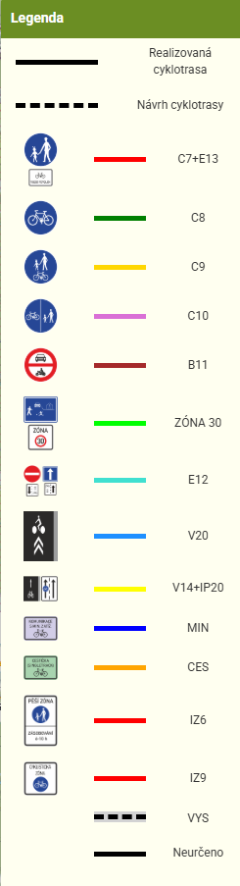

### Section C

### This part of the desktop does not contain any tools. Only the graphical scale and the logos of the map sources can be found here.

# Working with data

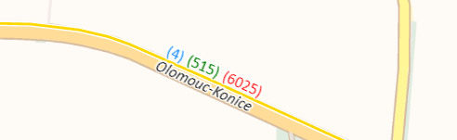When viewing the lines on the map portal, you will see numbering above the lines in three colours - blue, green and red. These numbers indicate the number of cycle paths that run along that line.

* Blue numbers indicate cycle routes that remain unchanged
* 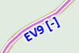Green numbers indicate the cycle routes proposed
* Red numbers indicate routes to be cancelled

Below the lines you can see dark blue text informing you that the EuroVelo route runs along this segment of a cycle path.

## Working with data in the viewing mode

The work with data in viewing mode is limited to viewing only.

The basic information about the line is displayed when the mouse is moved over the line. The line is highlighted and 3 attributes are displayed:

1. Traffic regime of the line
2. Pictograms
3. 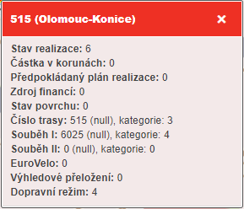Information on implementation

## If you need more information, just left-click on the line and a table with detailed information will appear.

## In the table you will find information on implementation, amount, source of funding, and most importantly the numbers of cycle routes along the line, and more.

EDITING

MODE

## Editing mode

 Editing mode is designed for working with data - editing current data and drawing new data. You need to log in to the edit mode using your username and password. The login form can be accessed in two ways. The most common way to log in is to click on the icon  at the top of the desktop ( Section A). When you click, you will see a table asking you to fill in your username and password. When you click *Log in*, the edit mode workspace loads. The second way to access the login form is to type **/login** after the web address *(eg.: mskr.stavbycyklo.cz/login)*

The edit mode workspace is similar to the view mode workspace. For the purpose of presenting the workspace, we have divided it into 4 sections. We have already seen sections A, B and C in the viewing mode, but the important section D is new.

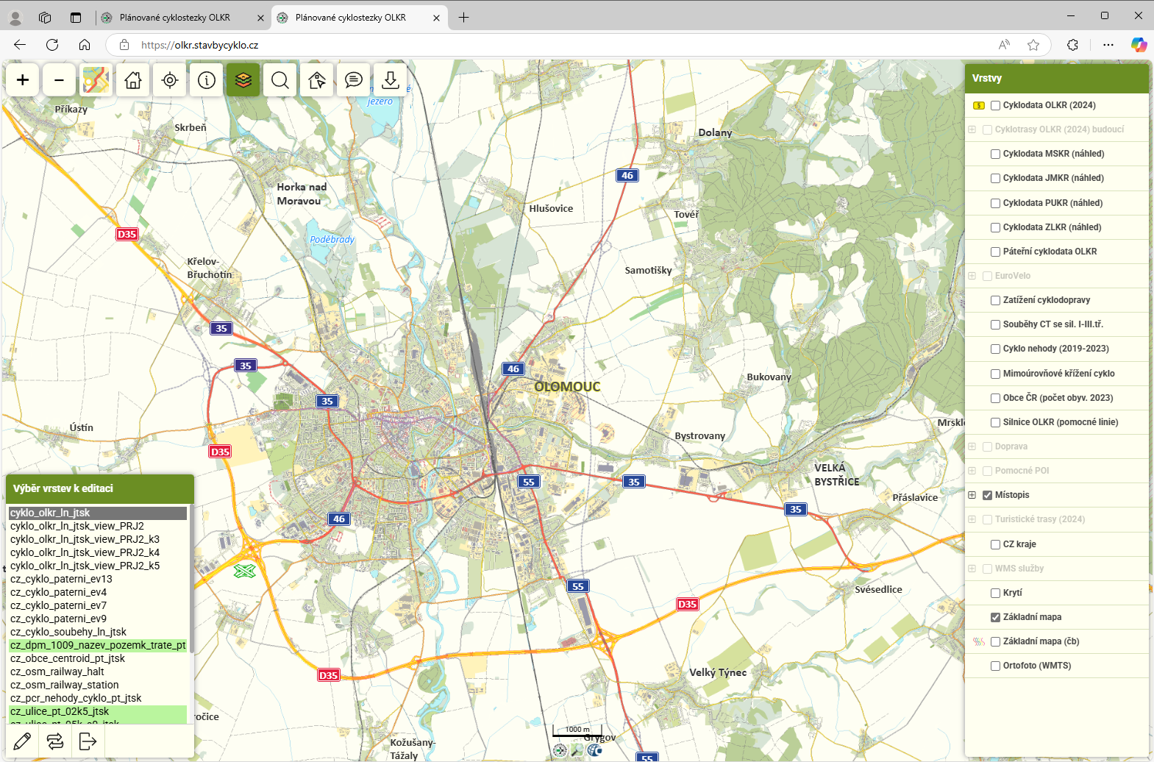

D

A

B

C

### Section A

In the first part of the workspace we find 11 tool icons. Some of them we've already seen in viewing mode, others are new here.

Download/

upload layers

Real estate cadastre

List of layers

My position

Change the map base

Zoom in the map



Notebook

Search

Legend

Default range

Zoom out the map

The first 9 icons are the same as in viewing mode. Their description can be found in the chapter dedicated to the description of Section A of the map portal window in viewing mode.

* ***The first two icons***  **and**  **are used to zoom in and out of the map.** You can also use the mouse wheel to zoom the map.
*  Click on *the third icon* with the map  to display the **menu for selecting the map base**. You can select a basic colour map, a black and white version or an orthophoto map (aerial image).
* *The fourth icon*  is used to return to the **home position** on the map.
* *The fifth icon*  is used to zoom the map to the **current location**. You need to have location sharing enabled to use this option.
* *The icons six, seven and eight are the icons used to display the* ***various work windows*** *in Part B.* Clicking on the *sixth icon*  displays the legend, clicking on the *seventh icon*  displays the list of layers, and clicking on *the eighth icon*  displays the search window. The currently selected option is highlighted in green. To hide the window, just click on the icon again.
* Use the *ninth icon* to activate the option to display **information from the Real Estate Cadastre**. Clicking on the desktop will open a new browser window at <https://nahlizenidokn.cuzk.gov.cz/>. If this option is activated, the icon is green.
* After clicking on the *last icon*, a window for **logging** into the portal's editing mode will appear.
* 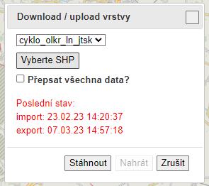The last two icons are new here. Clicking on the first of them  ** the Notebook window appears in Section B. See the description of Section B Notebook window.
* The second new icon  located in the last place is used to import and export data. Clicking this icon will bring up a new *Download/Upload Layer* window in the middle of the desktop. You will learn how to work with this tool in the Export and Import Data chapter.

### Section B

The second part of the desktop changes based on what the editor selects by clicking on the icons in Section A. By default, this section displays the *Layers*. You can also use the icons in Section A to display the *Search*, the *Notebook*, or the *Legend* window.  

You can also hide this section completely by clicking on the icon in section A of the currently displayed window. *(i.e. I have the Legend displayed, so I click on the Legend icon and the whole section is hidden.)*

 *Layers window -* you can turn on and off the map layers. The most important is the data layer - it should always be turned on by default. This layer is called **Cyklodata XXX (2025)** where XXX is the region abbreviation and the date is the date the data was updated.

 *Search window -* you can search and filter published data using various filters.

 *Legend window -* here you find the legend of the displayed lines. The legend displays abbreviated names with the line color and pictogram displayed. In case the visitor does not know what the respective abbreviations mean, it is possible to hover over thelegend itemand a description of the item will be displayed.

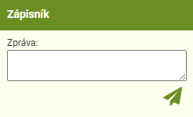** *Notebook window -* In this window you can record notes or send messages. These entries are saved directly to the portal and can be seen by all users logged into edit mode. To send a message, use the icon **. Sent messages can be edited or deleted using the corresponding icon next to the displayed message (delete - basket and edit - pencil). The message view also displays the name of the user who sent the message.

### Section C

This part of the desktop does not contain any tools. Only the graphical scale and the logos of the map sources can be found here.

**Please note:** If you happen to find that the selected base is not loaded when selecting map bases, this may be due to missing data. We recommend switching to Orthophoto. The data is gradually being added.

### Section E

This section is displayed only in the map server's edit mode.

After a successful login, this section displays a table with editable layers. To start editing, you need to select the layer you want to edit from the list (the layer is marked in grey) and then click on the pencil icon . This will turn on editing for that layer.

There are two more icons in the window - the icon with two arrows  will reload the layer from the server, and the last icon  will be used to log out of the editing mode.

**Editing toolbar**

After selecting the layer to be edited and turning on editing, a new toolbar appears on the desktop. This panel contains the editing tools.

Log out

Import GPX

New point from coordinates

Connect the lines

Move to another layer

Save

Cancel/

Close



Reload layer

Snap to

Move the object

Split the line

Duplicate

Create by drawing

* *Save* – This function is clear. Use this button to save your edits.
* *Create by drawing* – This function is used to create a new line.
* *Cancel/close* – Closes editing of the selected layer
* *Duplicate* – This function can be used to duplicate a selected line. The line is copied to the same place, so the duplicated object must be moved using *Move Object*.
* *Move to another layer -* This function allows you to move the selected object between layers.
* *Split the line* – This function is used to split lines.
* *Connect the lines* – This function allows you to connect two adjacent lines.
* *Move the object* – This function is used to move the selected object around the desktop.
* *New point from coordinates* – Used to create a new point.
* *Snap to* – When this function is activated, the exact connection (magnetic connection) of the line break points is made when adjusting the lines or creating new lines.
* *Import GPX file* – This button can be used to load objects in a GPX file into the layer.
* *Reload the layer* – This function reloads the edited layer. It is used when the layer is incompletely loaded.
* *Log out* – Logging out of edit mode

# Working with data

Obsah obrázku kartáček na zuby, nářadí, design

Obsah vygenerovaný umělou inteligencí může být nesprávný.When viewing the lines on the map portal, you will see numbering above the lines in three colours - blue, green and red. These numbers indicate the number of cycle paths that run along that line.

* Blue numbers indicate cycle routes that remain unchanged
* Obsah obrázku Barevnost, Písmo, Grafika

  Obsah vygenerovaný umělou inteligencí může být nesprávný.Green numbers indicate the cycle routes proposed
* Red numbers indicate routes to be cancelled

Below the lines you can see dark blue text informing you that the EuroVelo route runs along the cycle path segment.

## Working with data in editing mode

The data in editing mode is mainly worked with the editing toolbar (creating new lines, duplication, connecting and splitting lines, etc.) or the attribute table.

**Please note**: In the map portal environment, the DELETE key is set to delete lines. To delete text in cells, you need to use the backspace key..

### Creating a new line

### To create a new line, use the Create by drawing icon (pencil icon). When you click on it, a blue dot will appear next to the cursor. Then just left-click on the map to create the future line. Once the entire line is drawn, just double-click the left button and the attribute table will appear. The creation of the new line has to be confirmed by Saving ( diskette icon).

### Deleting a line

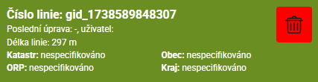You can delete the lines in the attribute table using the red icon with the trash can. Deleting a line can also be done by pressing the DELETE key..

Once you click the icon, the attribute table disappears and you need to confirm the deletion by Saving ( diskette icon).

Deleted lines are not deleted permanently, you can still find them in the database, they just have a "deleted" attribute.

### Duplicating a line

To duplicate a line, simply select the line you want to duplicate and press the Duplicate icon (two pages). The line will be duplicated in the same place, so you then need to move the duplicated object using Move Object. The duplication must again be confirmed with Saving (diskette icon).

### Splitting the lines

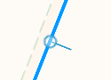In case you need to split an existing line, use the Split Line icon (scissors). After activating, the icon turns green, next, mark where the line should be split. The line can be split both at the breakpoints and in the course. If the Split function is correctly activated, a circle with a line will appear when you hover over the line (see picture on the right) and the line will lighten.

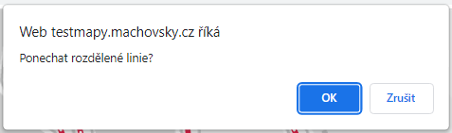After clicking on the split point, you need to deactivate the splitting function (click on the scissors icon again). A window will pop up asking *Keep the lines split?* Select OK. As with the other editing functions, confirm the split by Saving (diskette icon).

### Connecting the lines

To connect lines, select the Connecting Lines icon (connected circles). You must always have two directly adjacent lines selected. After the connection, confirm again with Saving (diskette icon). Select multiple lines by holding down the Shift key and clicking with the mouse on the lines you want to connect.

The attributes for the newly created line are specified on the basis of the first selected line.

### Move the object

When moving the object, you need to activate the corresponding function (icon with arrows). Then you can use the mouse to move the selected object on the desktop. After successful movement, deactivate the function and confirm by Saving (diskette icon).

**Line course adjustment**

In case you just want to adjust the line, click on the line and move the breakpoints (orange points on the line) to adjust the line to the desired shape. It is also possible to create new breakpoints by clicking on the line and holding down the left button to move the breakpoint to the desired position. Confirm the editing by Saving again (blue diskette icon).

If you need to delete breakpoints, hold down the CTRL key and click on the breakpoints to be deleted with the left mouse button.

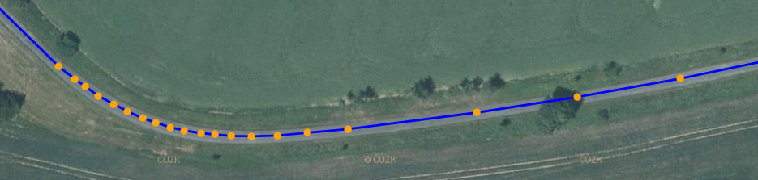

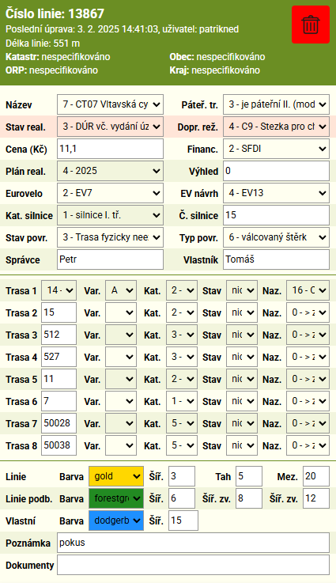

**Modifying attributes**

Attributes of a line are modified in the attribute table that appears when you click on the line. All attribute edits need to be confirmed with Saving (diskette icon) when the edit is complete.

In the attribute table you can find the following information:

* In the table heading you find basic information about the line:
  + number of the line
  + information about the last modification - who modified the line and when
  + length of the line
  + information on the territory

**Please note:** When editing attributes, do not use the DELETE key - this key is set in the map portal environment to delete lines.

Editable attributes:

|  |  |  |
| --- | --- | --- |
| Name | Name of route / route segment | In a situation when one of the backbone cycle routes runs along the line, it is possible to select it from the list. After selection, the information is automatically added to the *Route 1 attribute*. |
| Backbone cycle route | Backbone cycle route: significance I - red, II - blue, III - green | This attribute determines the significance of the route. 0 – not backbone 1 - backbone 2 - backbone I. (red) 3 – backbone II. (blue) 4 - backbone III. (green) |
| Status of implementation | Status of implementation of the cycle route segment | This attribute indicates the status of the implementation. Based on the implementation status, the line style changes (unrealized is dashed). You can choose from the following options: 0 - No design preparation started 1 - To be verified by study/investment plan 2 – Prepared study / investment plan 3 - Documentation for the issuance of a decision on the location of the construction, including the zoning decision  4 - Construction documentation (includes Documentation for building permit, Design documentation for construction implementation, Documentation for joint permit)  5 - Building / joint permit issued  6 - Implemented 7 - To be cancelled - other 9 – To be cancelled - high load communication |
| Traffic regime | Traffic regime for a cyclist on a given segment | This attribute indicates what traffic regime is on the line. According to the selected traffic regime, the Line (color) and pic attribute is automatically filled in.  There are 16 types of traffic regimes to choose from: 1 - C8, C9, C10, C7 + E13 (cyclists allowed) 2 - C7 + E13 - sidewalk (cyclists allowed) 3 - C8 – cycle path 4 - C9 - Path for pedestrians and cyclists - shared 5 - C10 - Path for pedestrians and cyclists - divided 6 - B11 - No entry for all motor vehicles 7 - Pathways, unmarked paths, single tracks 8 - Measures in the main traffic area 9 – Calmed zone (Zone 30, residential) 10 - E12 - Two-way cyclist traffic 11 - V20 - Pictogram corridor 12 - V14+IP20 – Cycle lanes 13 - MIN - Communication with minimum load (1,500 cars/day) 14 - VYS - High load communication 15 - IZ9 - Cyclist zone 16 - IZ6 – Pedestrian zone (cyclists allowed) 17 - B1 |
| Price (CZK) | Amount in millions CZK (incl. VAT) | The amount to be entered is in millions of CZK |
| Funding | Source of funding | The attribute indicates the source of funding. There are 10 options to choose from: 1 – Own resources only 2 - SFTI 3 - Regional allowance 4 - IROP 2021-2027  5 - IROP - ITI 2021-2027 6 - IROP - CLLD 2021-2027 7 – European funds 2000–2020 8 - Interreg; boarder cooperation 9 – Segment built within the framework of the Comprehensive Land Improvements (SPÚ) 10 - Segment built as part of other constructions (ŘSD, SŽ, Závody Povodí,...) |
| Implementation plan | Estimated implementation plan | Option to select the year of planned implementation. You can choose years up to 2030. |
| Outlook | Outlook |  |
| Eurovelo | Classification of the EuroVelo cycle route network | In case of the EuroVelo route following the line, it is possible to choose from 4 routes running through the Czech Republic. |
| EuroVelo proposal | Proposal for new EuroVelo routing | This attribute is used to record the proposal for a new EuroVelo routing. |
| Road category | Road category | Here is the category of a communication 0 - unspecified 1 - class I roads 2 - class II roads 3 - class III roads 4 – no category |
| Road number | Road number | This attribute informs about the road number |
| Condition of road surface | Condition of road surface in terms of transport services | The attribute indicates the condition of the surface on the given segment. There are 3 options to choose from - Conforming, Non-conforming and The route does not actually exist. |
| Surface type | Surface type | Specification of surface type 0 - unspecified 1 - tarmac 2 - concrete paving 3 – stone paving 4 - soil 5 - unrolled gravel 6 – rolled gravel 7 - sand 8 - grass 9 - poured concrete 10 – wooden boards 11 - metal grid |
| Manager | Manager | Information about the manager |
| Owner | Owner | Information about the owner |
| Route No. 1  Route No 2  Route No 3  Route No 4  Route No 5  Route No 6  Route No 7  Route No 8 | Records of the running of marked cycle routes | The Route attribute records the cycling routes along the given line and consists of 4 sub-items. - Cycle route number - Cycle route segment variant - Cycle route category - Status - Cycle route name  When filling in the cycle route number, the category of the route is automatically filled in. For each cycle route the status - cancel, keep/remain or proposed - must be indicated. Based on the status entered, the existing and future routing is then specified. |
| Line | Line | In this attribute the color and size of individual lines can be changed. This attribute changes automatically based on the selected traffic regime. |
| Line underline | Line thickness after selection | The values for this attribute specify the thickness of the line and its underline after selection. |
| Custom underline | Custom underline | It can be used to underline the lines. For example, to mark the lines you are currently interested in. |
| Note | Notes |  |
| Documents |  |  |

### Data backup

Data backup is performed automatically. Currently, the backup is set up so that every day during the night all data from all regional projects are individually downloaded as SHP and saved to the server in a ZIP file.

Backups are traceable back 1 week on the website. Backups can also be manually exported. We recommend backing up after major jobs, at the end of working hours, etc.

**Data export and import**

Data stored on the map server can also be edited by importing new data that overwrites the original data. You can also download data from the map server. The import and export window can be accessed using the icon  in section A.

**Data import**

When importing, first select which layer to upload to. Then use the "Select SHP" button to select the SHP file with the data you want to upload from your computer. Next, we select whether we want the uploaded file to overwrite all the data or not. Once everything is ready, press the "Upload" option at the bottom of the window.

If you are uploading new data to the portal and you do not check the option to overwrite all data, the newly uploaded data will be highlighted - the Custom Underline attribute will be set to pink with a width of 15.

**Data export**

When exporting, first select the layer you want to download from the list (red part). Then just press the "Download" option at the bottom of the window.

**Please note:** Before uploading data to the map server, the SHP file and other associated files (e.g. DBF, SHP, SHX, PRJ, CPG, SBX) must be packed into a ZIP file. There MUST NOT be a file with XML extension in the created archive! When importing, the data must be in S-JTSK projection..

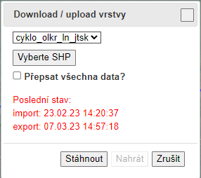

Last import/export time information

Select whether the uploaded SHP should overwrite the data

Selecting the location of the SHP file with new data

Selecting the layer we want exportovat/importovat